Question 1
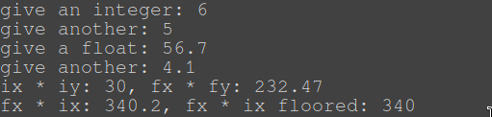

Question 2
The swap function with the references was easiest to use. The one with pointers worked, but wasn’t as convenient to use. The one without anything was a pain to make and didn’t really do anything
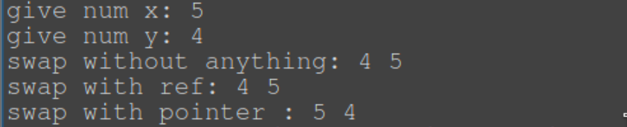

Question 3
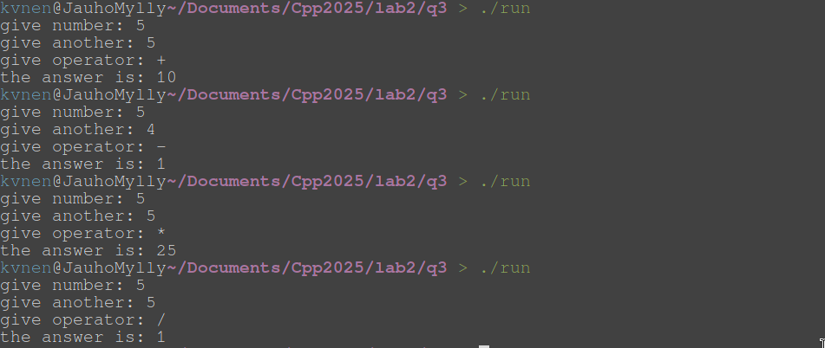

Question 4

Question 5
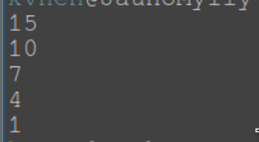

Quesiton 6
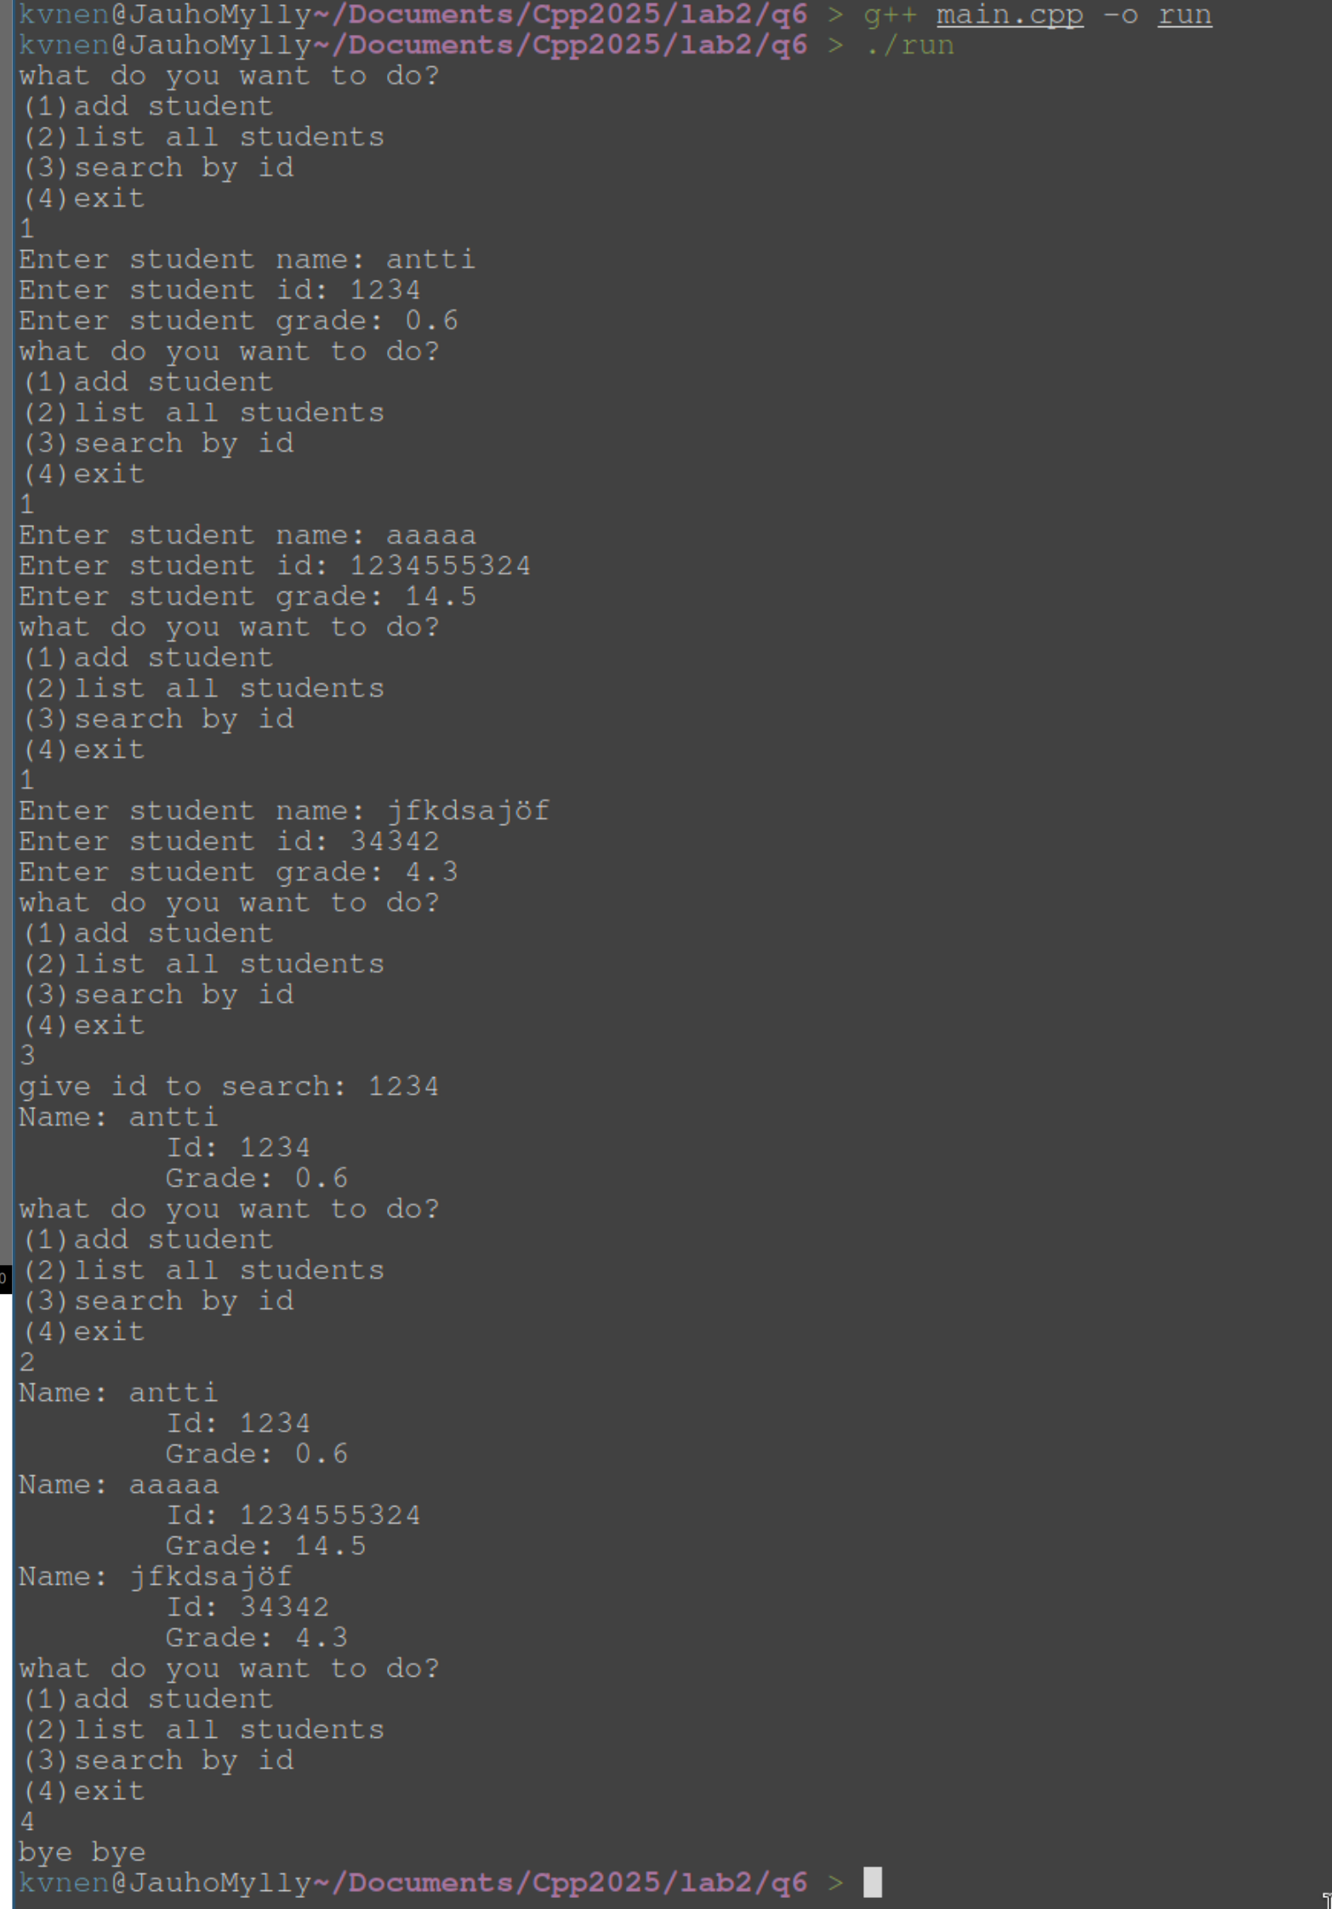

Question 7
The same variable can be accessed and modified from both pointers.


Question 8
Changing the reference changes the actual variable.


